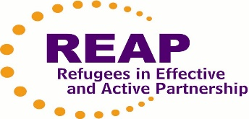

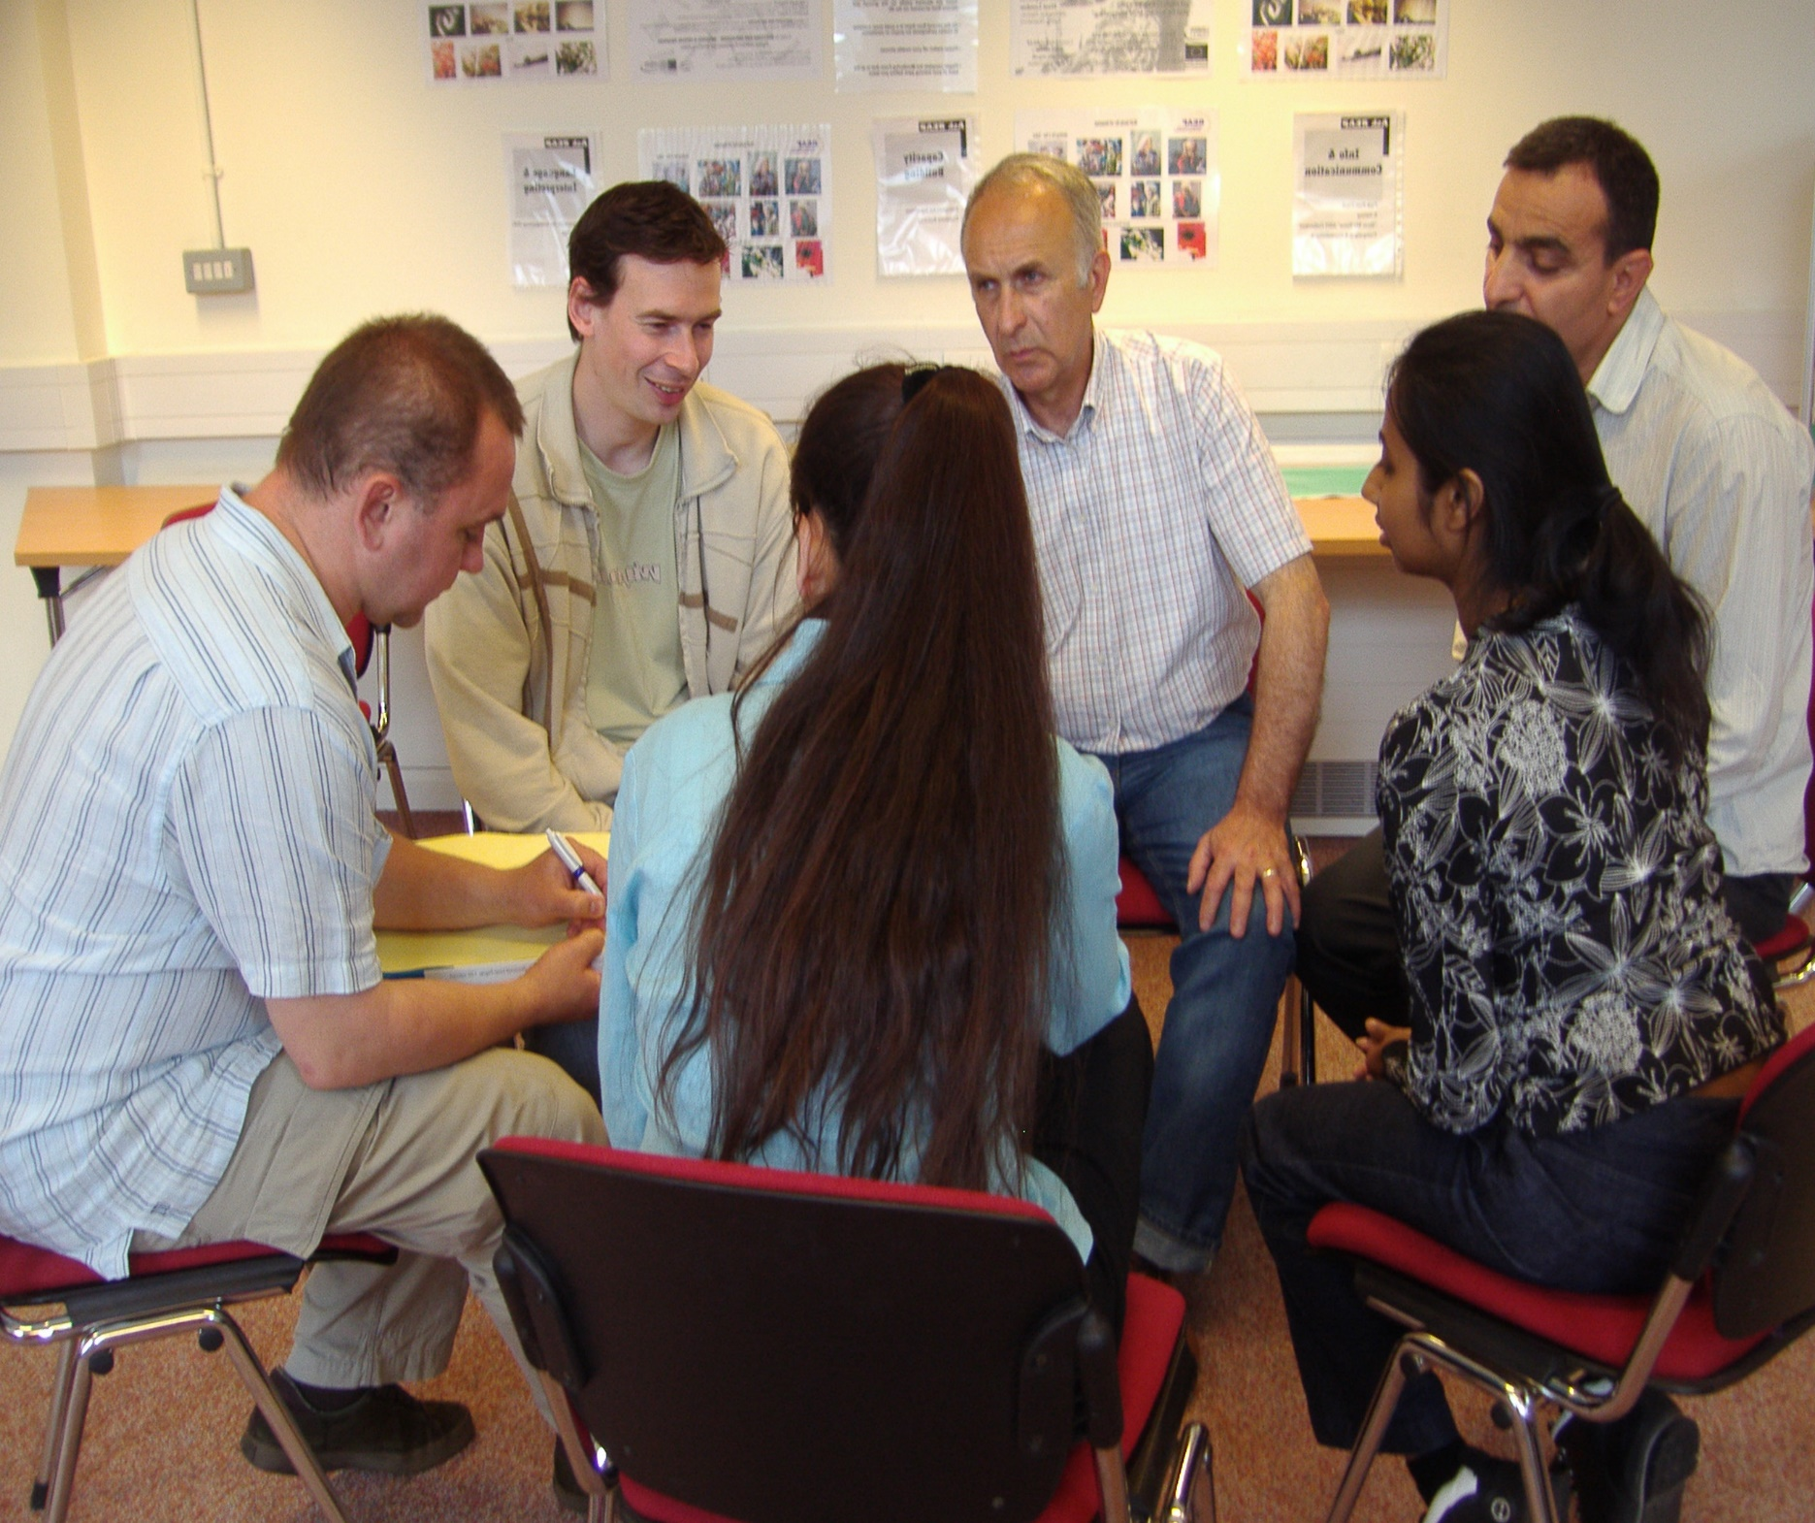

**Community Interpreters Training**

**Introductory Training IN PERSON *ONLY***

***When?***

*Next Course starts* ***January 2025***

***TASTER session Thursday 5th Dec 2024 9.15 - 1.00***

***FULL COURSE 4-workshops = 1 each week 9.15 – 1.00***

*Starts* ***Thursday 30th Jan, 6th Feb, 13th Feb, 27th Feb*** *(with lunch)*

All workshops 9.15 registration to 1.00

**You must be on time and attend all 4 workshops**

to complete the course and receive a Certificate of Successful Completion

You will have extra work to do between workshops

***Please contact us to book NOW***

***(Book your place early, as the course can be full)***

***Whatsapp*** *REAP 07983 419388 or interpreting@reap.org.uk*

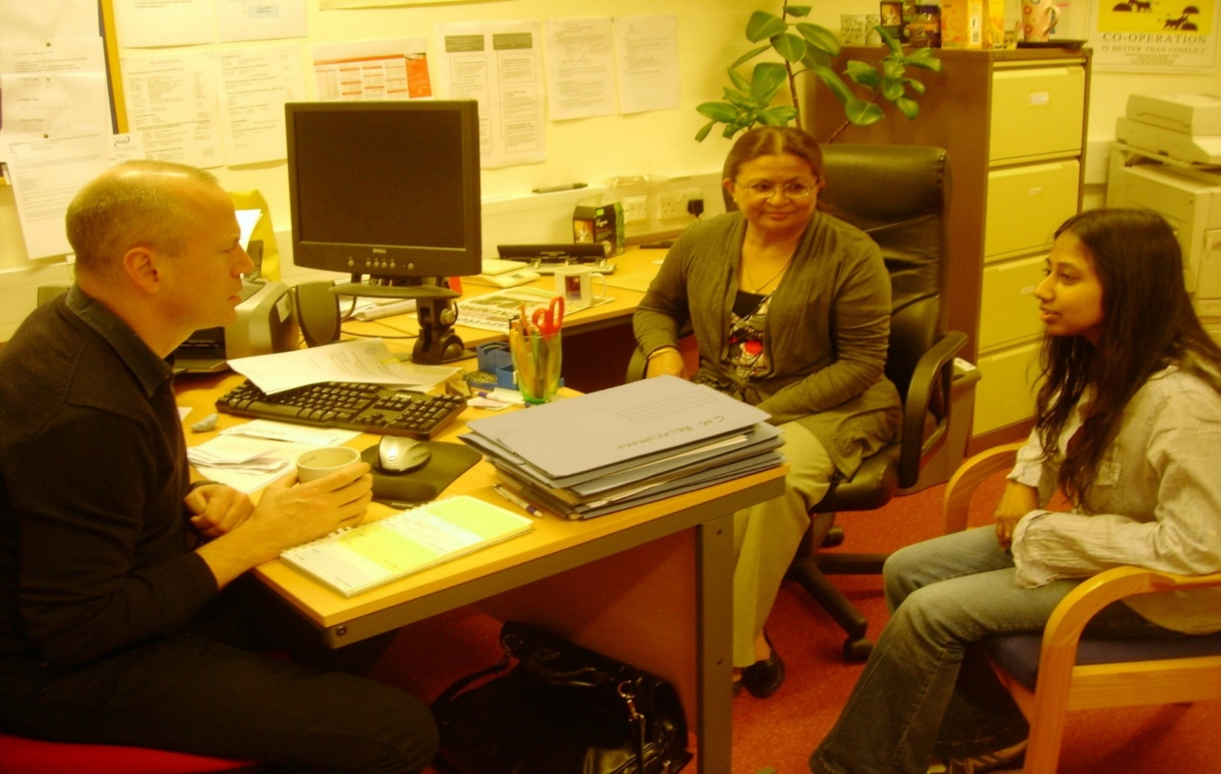

***Where?* Yiewsley Methodist Hall** (Upstairs), **Fairfield Road UB7 8EY,**

(Elizabeth Line-West Drayton, Buses 350, 222, U3, U5)

|  |  |
| --- | --- |
| ***How much?*** (for all 4 workshops):  ***FREE* for Asylum Seekers**  **£16** if you get Universal Credit/ Benefits *(please show evidence)*  **£32** waged **£47** if sponsoredby interpreting agency | Please pay at 1st workshop  Please bring evidence if you get benefits  *or* **We can send an invoice**  **for payment by BACS**  **We always give receipts** |

**We are also looking for ways new interpreters can get experience, please email us if you need trainee interpreters, volunteers or bi-lingual community ‘Connectors’**

**.**

REAP is a non-profit, refugee-led Charity (1103345) that supports refugees

as they rebuild lives as equal members of British society.